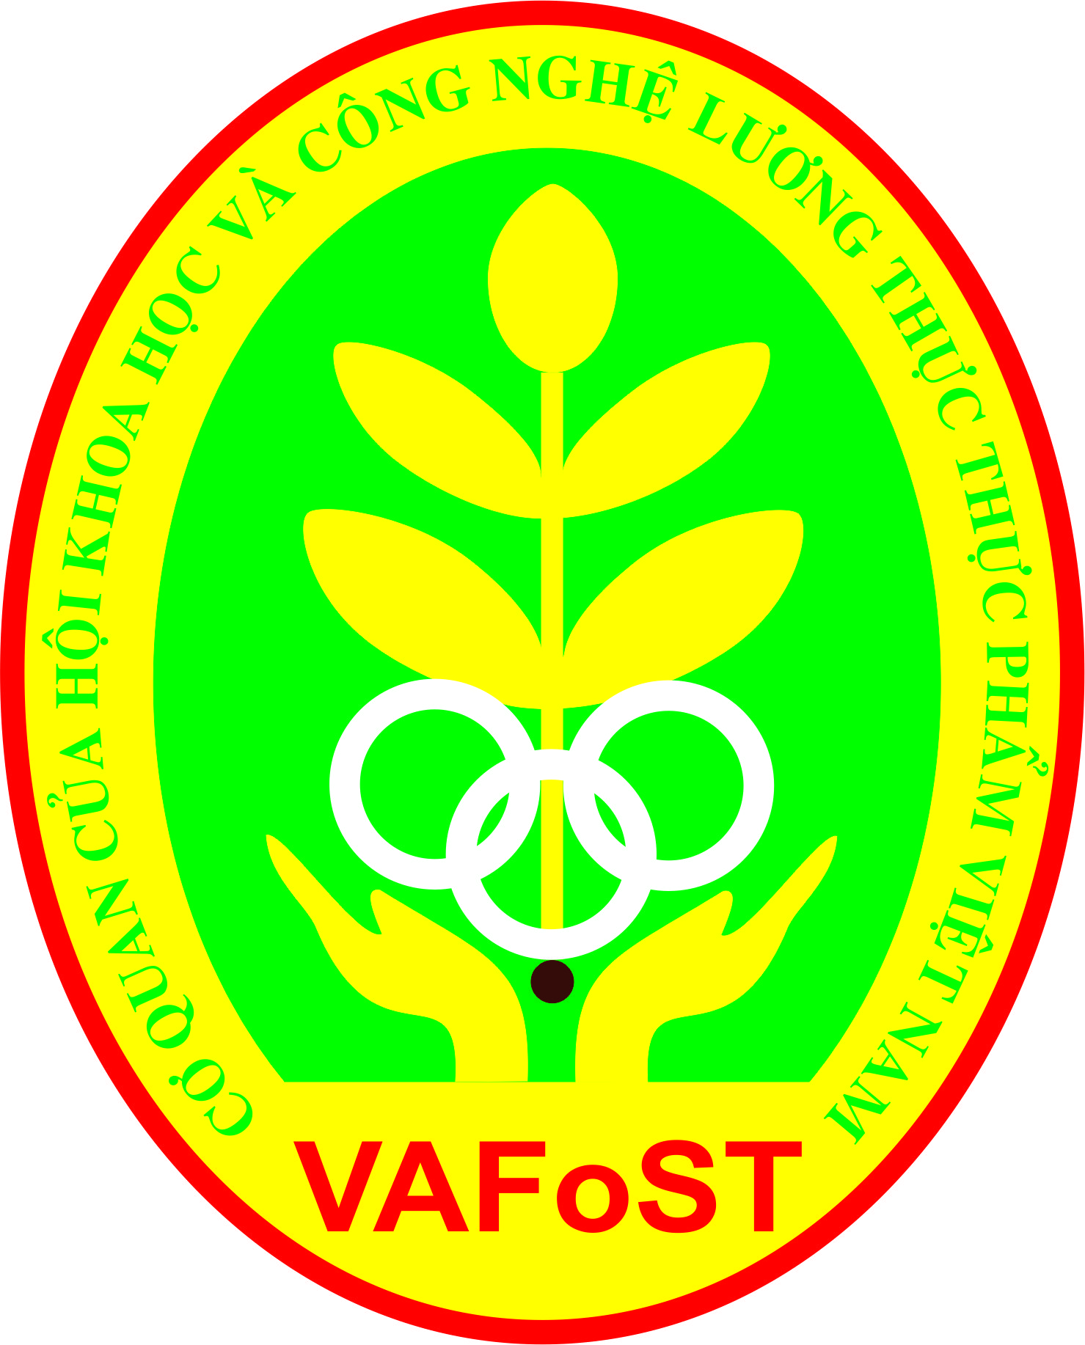

**THE ANNUAL VAFoST**

**YOUNG ACHIEVERS’ SAFE FOOD AWARD**

**“Greener food products for the ASEAN consumers”**

1. **GOAL OF THE COMPETITION**

Under the framework of the International Exhibition and Conference FI Vietnam 2016, the “YOUNG ACHIEVERS’ SAFE FOOD COMPETITION” is organized by VAFoST in partnership with UBM, and with the support of Saigon Technology University. This competition aims to provide opportunities for Food Science & Technology students fromuniversities, colleges and vocational schools in Vietnam and Cambodia to create new food products from innovative usage of raw materials and food ingredients that will capture the emerging needs of growing segments among the 600 million consumers in ASEAN.

**COMPETITION CRITERIA**

- The products must be made from the domestic material resources.

- Food ingredients must be used to create new products.

- Students are encouraged to create new food products (e.g. new formulation, new product formats, new packaging) thathas economic and technical feasibility.

- Food product prototypes are to be produced and displayed in the contest.

1. **COMPETITION PARTICIPANTS**

Undergraduate students from universities and colleges with Food Technology programs in Vietnam and Cambodia.

1. **JUDGING PANEL**

Preliminary Round

- VAFoST’s representatives

- Representatives from participated universities, colleges and schools

Final Round

- IUFoSTscientists

- VAFoST’s representatives

- UBM’s representatives

- Industry representatives

1. **PRIZE**

- One first prize (the winner): UBM prize (1,000 USD)

- One Second prize (1st runner up): VAFoST prize

- Two Third prizes: STU Prize

1. **REGISTRATION**
   1. **Registration time: from 1 to 8/04/2016 (before 17h00)**

Through email**:** [**vafost.yasfa@gmail.com**](mailto:vafost.yasfa@gmail.com)

* 1. **Registration form:**

Send the brief product development proposal (300 words) that includes:

- Product name& type

- Target consumers

- Materials and ingredients to be used

- Description of process, product benefits and potential packaging options

Email subject: **Entry for Young Achievers’ Safe Food Competition 2016**

* 1. **Requirements for the shortlisted entries**

- The proposals must be written in English.

- Product ideas are original and have not been enrolled in any other competitions.

- Product concepts are for packaged food, stable in room temperature condition without being refrigerated or frozen.

- The products have marketability and fit the theme “for ASEAN consumers”.

1. **ANNOUNCEMENT OF TOP 20 AND JUDGING OF TOP 10 FINALISTS**

**Qualifying round**

VAFoST judges will select the top 20products as finalists. Contestants will be notified via emails and phone calls by **22/04/2016**. Each finalist will receive funding of 1,000,000 VND from UBM to produce the actual product. These products will all be on display at the Fi Vietnam 2016 exhibition. Top 20 are requested to submit their prototypes by **06/05/2016** to the address below:

|  |
| --- |
| **FACULTY OF FOOD TECHNOLOGY - C.104**  **SAIGON TECHNOLOGY UNIVERSITY**  **180 CAO LO, WARD 4, DISTRICT 8, HOCHIMINH CITY**  **PHONE: (08) 38505520 – Ext: 130FAX: (08) 38508259** |

**Final Round**

On 18/05/2016, out of the 20 shortlisted prototypes, the 10 best picks from the final assessment and sensory evaluation will have a chance to defend their products in front of an nternational panel from IUFoST and FIFSTA to compete for First, Second and Third prizes.

The final results will be announced at the opening ceremony of Fi Vietnam conference on 19/05/2016.

Chair – Organizing Committee

(Signed)

**Prof.LuuDzuan**

**Vice-President,VAFoST**

**Dean – Faculty of Food Technology, STU**